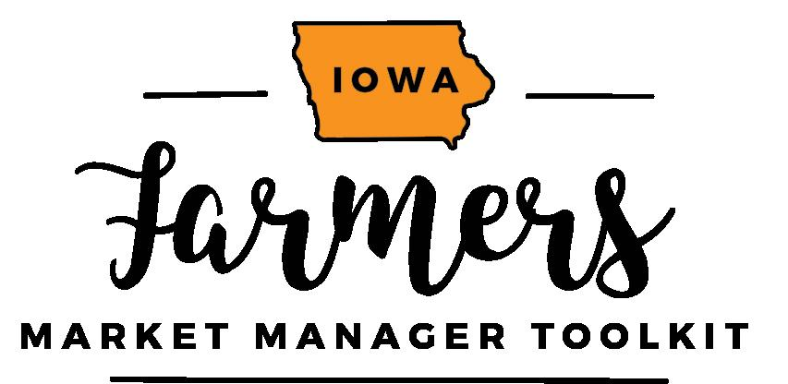
Cultivating Broader Support for your Market // Sponsorship & Stewardship
Example Email / Letter
Notes:
- Consider your capacity as a market manager throughout the year and coordinate your asks, activities, and stewardship accordingly.
- Have patience, positivity, perseverance.
- Remember that you already have fans, supporters, and people who are willing to invest their resources in your market’s success, you just need to speak their language, offer genuine appreciation at the right times, and keep good records.
- Start and end in a place of thanks.
- Set boundaries, schedules, and clear expectations for yourself and your supporters.
- The dynamic between market manager and vendors can sometimes be challenging. Adding a community component alleviates some of this tension / “hot potato” game of responsibility.
- Do you need a small committee or are you as the manager making the ask? Consider how this changes the feel of the correspondence. “We” versus “I”
It’s okay to have the first year be a year where you build a core team and then work together in the second year to implement a strategy.
-----------------------------------------------------------------------------------------------------------------------------------------------------
Dear ______,
Creating a connection that feels real
Even in the depths of Iowa winter, our vendors and managers are busy getting ready for the fast-paced farmers market season. Bob from Sunshine Tomatoes is planting seeds in his hoophouse, Emma Smith is doing crop planning for Bluebirds veggies, and I’m processing more than 100 vendors forms. As a market manager, right now I’m in a place of reflection (our market last year was a great success!) as well as a place of energized planning (Let’s make this market even better!). I’m reaching out to you because I know you value local foods and are likely a market customer already.
Our farmers market is in its XX year. // Our farmers market has been in operation since XXXX. We contribute our success to dedicated vendors, regular customers, and a lot of behind the scenes work by staff and volunteers. In January, February, and March we are X, X, and X.
What is special about your market?
Our market brings in X customers and visitors each Saturday.
Our market has the highest quality vendors in Eastern Iowa. We prioritize quality produce.
Our market is a community event that offers food, music, and a wide variety of produce and crafts.
Getting perspective / Education
The marketplace for fresh fruits and veggies is always evolving. Our farmers market needs to recognize all the significant and subtle changes and be proactive in our own evolution. Our market is an important place for small business start-ups, a driver of social change, and a community hub where in-person connections and quality products are celebrated.
Your specific request
In the spirit of expanding community support and building capacity and sustainability of the market, I’m hoping you can contribute in 2019 to one of our three goals. I would like to ask you to consider contributing your money, your time, or your voice:
202x Goal One: $1,000 for Marketing and Promotion
It’s important for our market to reach new customers. This year I would like to do 10 boosted Facebook posts, 5 radio ads, and handout 500 magnets with our summer market schedule. The burden of advertising and promotion can fall disproportionately on the market vendors. I’d like to advertise the market as a whole in these three strategic ways. This is a great option for you if you love the market but don’t have time to contribute as a volunteer or host or if you’re an inconsistent shopper but a lover of strong local food economy. XX is supporting this financial effort so checks can be made payable to X. Can you give money to help the market be more competitive in the media landscape?
202x Goal Two: Have 10 Engaging Market Hosts
Let’s build the capacity of the regular customers. I want you to know more about the market and I want you to bring your vibrancy into our market space so customers feel welcome. At each of our ten markets this year there will be a market host. The host will be a greeter, hand out vendor maps, and use a tally counter to help record customer attendance. There will be a one-hour training at the beginning of the season and one-hour training in the middle of the season. Hosts will be provided a market t-shirt and be invited to a cocktail party at the end of the market season to celebrate the year and learn about the market’s impact. Could this be your cup of tea?
202x Goal Three: Build Social Capacity
As the market manager I am able to do social media promotion for the market on the market’s page as well as my own. Vendors also promote on their own pages. Can we make this reach bigger and better? I’m hoping to secure a list of 20 people who will pledge to do five social media posts this summer for a total of 100 individual contributions of unique content that benefit the market. Can you pledge this time and effort? Maybe it’s a selfie with your favorite vendor? A meal you cooked with market ingredients? We will just ask that you use tag vendors when possible and the market. Can you be an influencer for local food?
Thank you for considering a contribution that matches your capacity and talent. Our farmers market adds so much to our community’s culture and our residents’ quality of life. Let’s make it a sustainable, growing part of Xtown’s future.
For any and all questions please contact me at name@email.org or by calling XXX-XXX-XXXX.
Best regards,
Community Market Manager

